This letter is subject to copyright until 17 August 2023

88.12.00
From Henrietta Wehl
RB MSS M100f, Library, Royal Botanic Gardens Melbourne.

With Ettie's love to uncle Ferdinand Xmas 1888

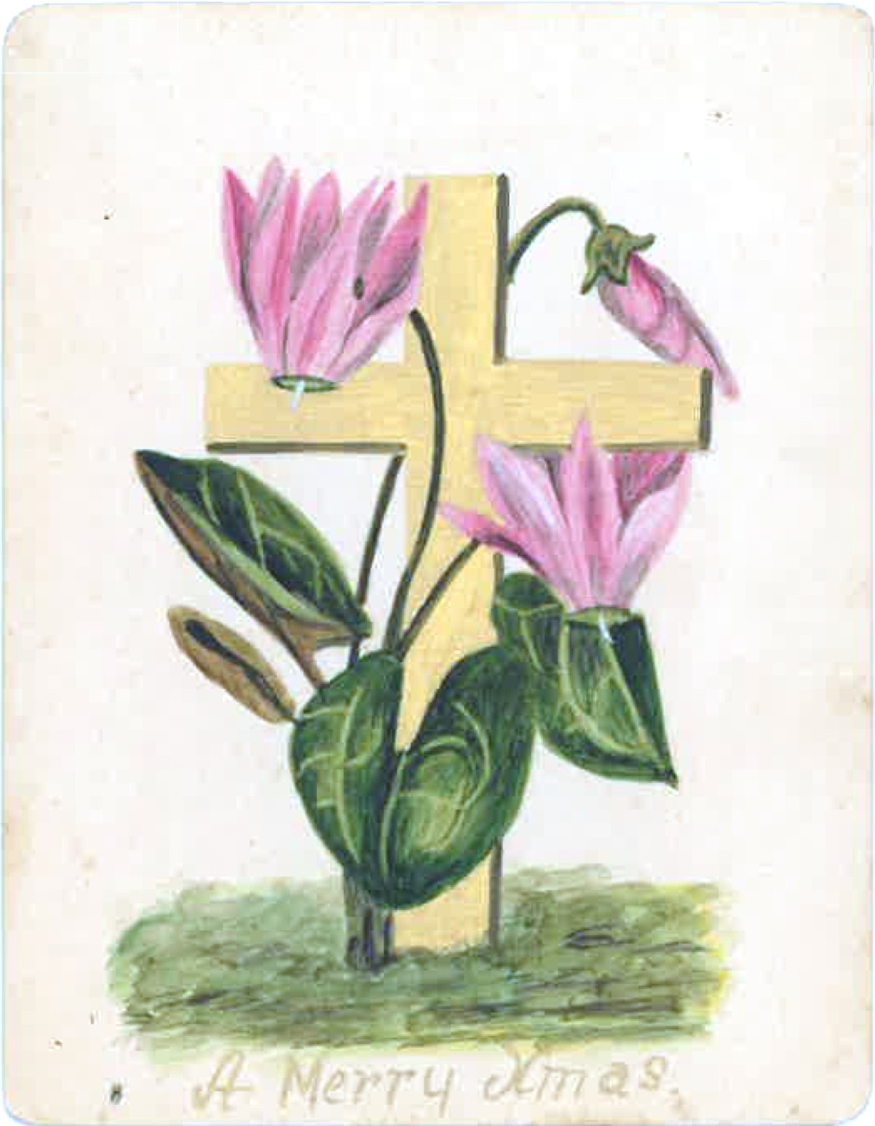

Text is written on the reverse of a hand-painted Christmas card depicting a pink cyclamen entwined around a gold cross, with ‘A Merry Xmas’ written underneath: 88-12-00_image01.jpg

